Task – 3 Longest Continuous Subarray With Absolute Diff Less Than or Equal to Limits

class Solution {
public int longestSubarray(int[] nums, int limit) {
Deque<Integer> increase = new ArrayDeque<>();
Deque<Integer> decrease = new ArrayDeque<>();

int maxLength = 0;
int left = 0;

for (int right = 0; right < nums.length; right++) {
int current = nums[right];

while (!increase.isEmpty() && current < increase.peekLast()) {
increase.pollLast();
}
increase.offerLast(current);

while (!decrease.isEmpty() && current > decrease.peekLast()) {
decrease.pollLast();
}
decrease.offerLast(current);

while (decrease.peekFirst() - increase.peekFirst() > limit) {
if (nums[left] == decrease.peekFirst()) {
decrease.pollFirst();
}
if (nums[left] == increase.peekFirst()) {
increase.pollFirst();
}
left++;
}

maxLength = Math.max(maxLength, right - left + 1);
}

return maxLength;
}
}

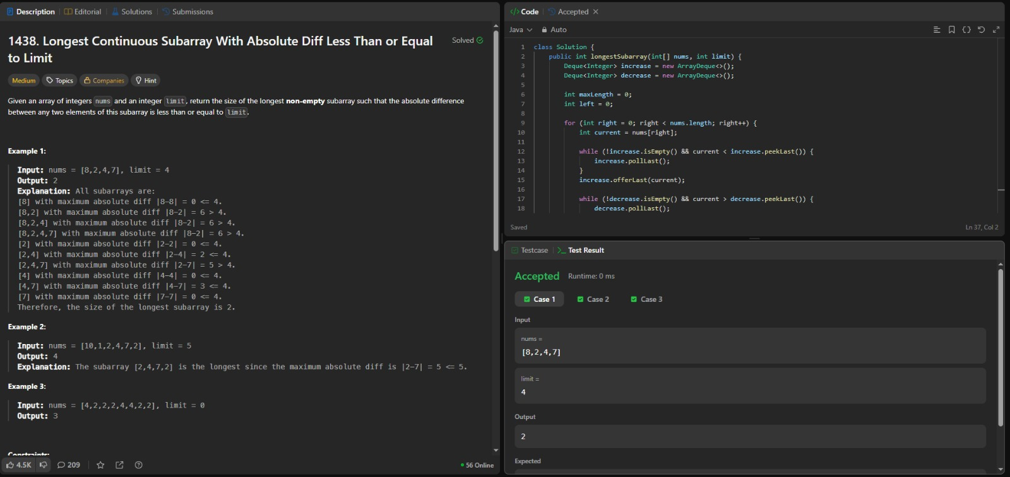
r

